Voluntary Cymru Committee Members
Information pack

Thanks for your interest in being part of Citizens Advice. This pack should give you everything you need to know to apply for this role and what it means to be involved in Citizens Advice.

In this pack you’ll find:
- Our values
- 3 things you should know about us
- Information about the organisation and role
- The benefits of volunteering with Citizens Advice
- Our approach to equality and diversity

Want to chat about this role?
If you want to chat about the role further, you can contact Fran Targett, Director Wales by emailing fran.targett@citizensadvice.org.uk

How to apply

Please provide a CV and or personal statement as outlined under the skills section below and send to angie.tattum@citizensadvice.org.uk

Our values
We’re inventive. We’re not afraid of trying new things and learn by getting things wrong. We question every idea to make it better and we change when things aren’t working.
We’re generous. We work together, sharing knowledge and experience to solve problems. We tell it like it is and respect everyone.
We’re responsible. We do what we say we’ll do and keep our promises. We remember that we work for a charity and use our resources effectively.
Things you should know about us

1. We’re local and we’re national. We have 6 national offices and offer direct support to people in over 290 independent local Citizens Advice services across England and Wales.

2. In Wales each year we help over 150,000 people solve almost 500,000 problems from over 250 locations.

3. We’re here for everyone. Our advice helps people solve problems and our advocacy helps fix problems in society. Whatever the problem, we won’t turn people away.

4. We’re listened to - and we make a difference. Our trusted brand and the quality of our research mean we make a real impact on behalf of the people who rely on us.

How our organisation works

The Citizens Advice service is made up of Citizens Advice - the national charity - and a network of around 300 local Citizens Advice members, 19 of which are in Wales  This role sits in the national charity, which includes  - 800 national staff working in one of our 6 offices, 2 of which are in Wales or as homeworkers, or as part of the Witness Service from over 240 courts across England and Wales  - 3,000 Witness Service volunteers  Our network members are all independent charities, delivering services from  - over 600 local Citizens Advice outlets  - over 1,800 community centres, GPs’ surgeries and prisons  They do this with:  - 6,500 local staff  - over 23,000 trained volunteers  Our reach means 99% of people in England and Wales can access a local Citizens Advice within a 30 minute drive of where they live. | 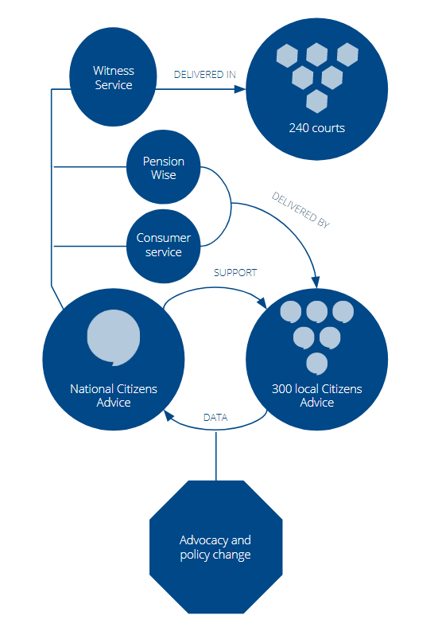

Citizens Advice Cymru
Citizens Advice Cymru
The Citizens Advice service helps people resolve their legal, money and other problems by providing free information and advice, and by influencing policy makers.
But we’re not just here for advice - we also use clients’ stories anonymously to campaign for policy changes that benefit the population as a whole. Information and advice is delivered by local Citizens Advice, providing face-to-face advice from over 250 locations including high streets, community centres, doctors’ surgeries and prisons; as well as via phone, email services and online via citizens advice.org.uk.
There are 19 local Citizens Advice across Wales, each a registered charity and company limited by guarantee. Citizens Advice is also a registered charity, and a membership organisation which provides training, information systems and operational support to the local Citizens Advice, and which campaigns at a national level. Citizens Advice is undergoing a transformation. Our strategic plan entails offering new services, new channels for accessing those services, as well as sharpening our support for the network of local Citizens Advice in a challenging funding environment. We are also engaging with governments about absorbing and developing a number of new areas of operation. The agenda entails some fundamental internal change.
The National Trustee Board
The National Trustee Board led by the Chair David Varney is the governing body and the policy making and standard setting body for Citizens Advice. It sets the policy of the charity, determines corporate strategy, including setting key strategic objectives, makes major decisions about the use of finances and sets a framework for human resources policy. It consults with its member local Citizens Advice and sets and monitors a framework of standards and policy.
Citizens Advice quality assures the individual local Citizens Advice providing advice and supporting them with the training, information and case management systems they need to deliver advice effectively. In addition, it runs some nationally funded programmes delivered through local Citizens Advice.
The Executive Team led by the Chief Executive, Gillian Guy, is accountable to the Trustee Board and has operational responsibility for the effective functioning of Citizens Advice.
The Citizens Advice Cymru Committee
The Committee, led by the Chair, is the body with specific responsibility for the development and review of strategy for the service in Wales.
The Wales staff team led by the Director, has operational responsibility for the effective functioning of Citizens Advice Cymru.
The role
We need members with a proven record of significant achievement in their own field within a substantial or complex organisation, operating at a strategic level, confronting challenges and driving through initiatives. Committee members’ skills complement rather than mirror the skills of our staff team. The Committee maintains a strategic focus across the Citizens Advice service in Wales and is not involved as a Committee in day to day operational work.
Successful candidates must be able to demonstrate they have the skills required to fulfil the fundamental responsibilities of all Citizens Advice Cymru Committee members. In addition to these fundamental skills, we are looking for specific skills which will strengthen the strategic capacity of the Committee. These skills are highlighted below and candidates must be able to demonstrate they have all the fundamental skills and at least one of the specific skills listed.

Fundamental responsibilities of members are:
- Formulating strategy – developing and maintaining vision, strategy and clear objectives for Citizens Advice Cymru in the best interests of the service’s clients.

- Ensuring accountability – being accountable to and consulting with local Citizens Advice, listening to their views and priorities and explaining Committee decisions. Holding the staff team, through the Director, to account for the delivery of the strategy, offering purposeful, constructive scrutiny and challenge.

- Shaping culture – being committed to the aims, principles and values of the Citizens Advice service in particular social justice, inclusion, equality and diversity. Providing visible leadership across the Citizens Advice service in Wales to develop a positive culture, ensuring this is reflected in their own and the Committee’s behaviour and decision making.

- Ambassadorial and intelligence – helping to build strong relationships with local Citizens Advice, funders, government(s), regulators and the corporate sector. Understanding the environment Citizens Advice Cymru and local Citizens Advice work in and the needs of clients, including the political context in Wales and Welsh language provision. Representing the Citizens Advice service to internal and external stakeholders and bringing back messages and information.

Skills
- Strategic capacity – successfully achieving transformation, change or growth in an organisation, thinking outside the box;
- Management experience - experience as a senior manager or Director/Trustee of a membership organisation or an organisation with widely dispersed service delivery.

- Customer service – ensuring customer focus maintained in designing and running service structures.

- Consumer advocacy and social policy – ensuring that the service is able to plan strategically to influence public and corporate policy as it impacts on consumers across Wales.

- Excellent networking and communication skills – working with leaders and opinion formers to achieve results, drawing on expertise developed in the corporate sector or local and national government.

- Fundraising and income generation.

Candidates are asked in their application to describe their skills and experience using the same numbering as the above to demonstrate how they meet the person specification.

Terms of appointment
Terms of Appointment
Committee membership is an unpaid voluntary role. Reasonable out of pocket expenses will be met. The role requires a time commitment of approximately two days per month. This includes three full day Committee meetings a year (one of them linked to a development day), attendance at a range of conferences and forums run by Citizens Advice and other working groups and sub-committee meetings as agreed.

Committee meetings are usually held in Shrewsbury and travel throughout Wales will be required. Successful candidates will normally be appointed for a three year term and can serve a maximum of six years. On appointment, members will meet with the Chair and/or Director to agree his or her role and commitments. New Committee members will receive a full induction on appointment including meeting with the Director Wales and other key staff, visits to local Citizens Advice and Citizens Advice Cymru offices will be arranged so that they can quickly get up to speed with the structure of and issues facing the Citizens Advice Cymru service. Trustees are expected to fully engage with local Citizens Advice and to make the most appropriate use of their skills and experience.

Legal compliance and code of conduct
Successful candidates will have to sign a Code of Conduct and must disclose any information which could conceivably bring the Citizens Advice service into disrepute. Certain people are disqualified by law from acting as charity trustees for example anyone with an unspent conviction for an offence involving deception or dishonesty or anyone who is an undischarged bankrupt and equivalent standards are applied to membership of the Committee.

Equality and diversity at Citizens Advice
Citizens Advice is fully committed to stand up and speak up for those who face inequality and disadvantage. We want this to be reflected in the diversity of the people who work for us.
To help us achieve this, we aim to make our recruitment process as fair as it can be. We also offer support to disabled candidates to make sure no one loses out on a role because of their condition.
- We offer a guaranteed interview scheme. If you have a disability and your application meets the minimum criteria for the post, we’ll interview you for it.
- We’re a Disability Confident employer. We’re committed to changing attitudes towards disability, and making sure disabled people have the chance to fulfil their aspirations.
- We’re part of the Equality and Diversity Forum. This means we’re committed to progress on age, disability, gender, race, religion and belief, sexual orientation and broader equality and human rights issues.

