Citizens Advice can help you regain your confidence and your financial independence TODAY!

Citizens Advice is part an exciting new project
Building Better Opportunities: Community Connections Essex
We are working together to help those furthest away from employment back into sustainable employment. This project is funded by the Big Lottery Fund and the European Social Fund.

We can support anyone who is:
- 16 years and over
- Out of work, education or training for more than 6 or 12 months depending on your age
- Economically inactive
- disabled or has long term health needs
- Requires support to fully and independently engage in existing services
- Wants to move towards volunteering, training or sustainable employment
- Living in Basildon, Southend or Thurrock

Services we provide
- One to one support and casework which may include developing personalised plans to deal with almost any issue
- Information, advice and guidance in areas such as money worries, benefit issues, housing and legal problems
- Provide practical help to manage your money so that you are able to maintain financial independence
- Better off calculations
- Refer you to partner organisations who can help with CV preparation, application support and job searching

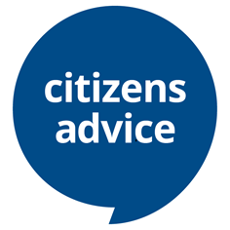
Unsure if you are eligible for this additional support, please contact us and we will be happy to help you:
Email: rachiel@bascab.org.uk
Telephone: 07879 740609

