Health-related outcomes toolkit

Research process overview
This document is intended to provide an overview of the research process for using the health-related outcomes toolkit.

The next page shows a flowchart of the entire research process, which should help with planning and resource allocation. The flowchart includes a key which directs the reader to specific parts of the toolkit, and shows at which stage of the process these should be used.

The flowchart is followed by notes which explain each stage of the process in more detail, and help the reader to think in advance about the details of their research project, and the decisions that will need to be made before they begin.

Project timescale and flowchart
The project can be divided into three main phases, each of which should take around one month to complete (although this depends on the scale of your project, and phase two may require longer depending on the length of time that project organisers judge as appropriate):

- The first phase will involve familiarising yourself with the resources and identifying an appropriate sample through advice sessions. If opting for the single-phase approach, you will need to record contact details for sample clients during their advice sessions. If opting for the two-phase approach, you will need to conduct the first survey with sample clients, as well as recording their contact details.

- The second phase is the waiting period between advice and follow-up; this period allows time for clients to take action and for outcomes to be achieved.

- The third phase will involve conducting the follow-up work with clients, and recording information.

 | Questionnaire and analyser guidance documents |  | Single survey approach: questionnaire OR  Two-stage survey approach: stage two questionnaire
 | Two-stage survey approach: stage one questionnaire |  | Single survey approach: analyser OR  Two-stage survey approach: analyser
Tools/documents to be used at the appropriate stage of the project – match to flowchart.
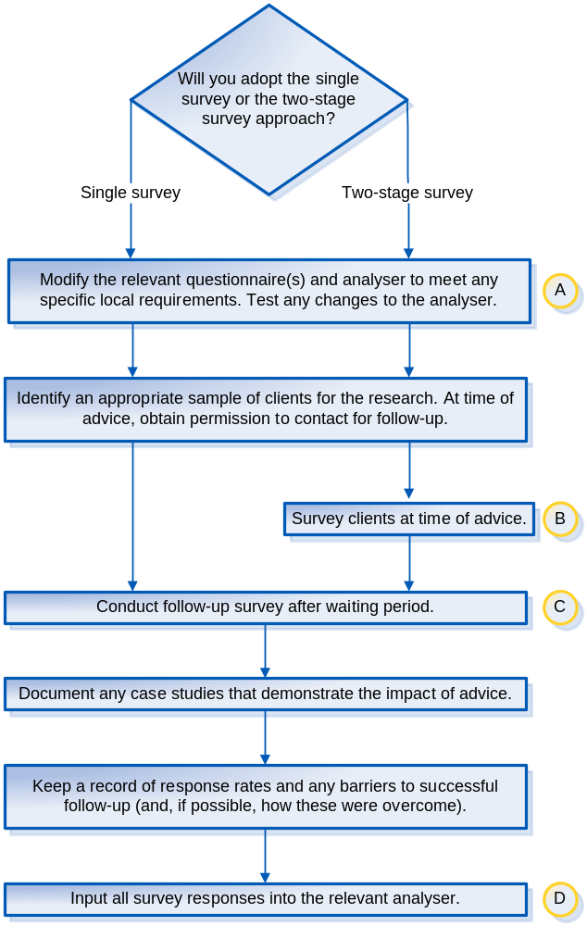
Phase 2

Phase 2

Phase 1

Phase 3

Notes on flowchart

Will you adopt the single survey or the two-stage survey approach?

You can approach the research project in either one of two ways:

- Follow up with a sample of clients after advice to conduct the single survey. (single survey approach)

- Conduct the survey in two stages: stage1 - collect baseline survey responses at time of advice and stage 2 - follow up with clients after advice for a second survey. (two-stage survey approach)

The purpose of this toolkit is to help demonstrate the changes to health-related measures that clients experience after seeking advice. To achieve this, information from clients is needed about their situation before advice and their situation after advice.

The two-stage survey approach is better suited to this objective, because it involves collecting information at both of these stages. Results can then be compared to make an objective observation of the difference that advice has made.

The single survey approach is less ideal because it requires clients to provide some of the information retrospectively. Information about both stages is collected at the same time, after advice. Inevitably, certain details are forgotten and perceptions change.

The drawback of the two-stage survey approach is that it will require additional resources. Some examples of where additional resources will be required are:
- Conducting an additional survey at the advice stage
- Ensuring that client responses can be matched between the two surveys
- Ensuring consistency between the two stages (either the same person conducting the survey on both occasions for an individual client, or tightly scripting the survey process).

Where resources are more limited, however, it may not be practical to adopt the two-stage approach.

It is important to choose an approach at an early stage because it will determine which parts of the toolkit will be used for the rest of the project.

Modify the appropriate analyser and questionnaire(s) ahead of data collection (if required)

If you want to make any additions to the questionnaires or analysers provided, you should do so in advance to allow time to test your changes. Please refer to the guidance documents for help using questionnaires/analysers.

Identify an appropriate sample of clients for the research

You might, for example, choose to survey all clients who are provided with advice within a certain time period e.g. all clients seen between the 1st and 10th June at a specific location. Alternatively, you might choose to survey all clients who enquire about a specific issue e.g. all debt clients seen in March. The size of the sample depends on the size of your organisation/service, although collecting a larger data set is likely to yield more meaningful results.

The reason for conducting research into samples of clients is that it allows make inferences to be made about the whole service. Recording the outcomes of no particular sample will not help to understand the proportion of clients who typically achieve an outcome, because an unknown number of outcomes go unrecorded. With a sample of clients, we know: a) the size of the entire sample, and therefore, b) the proportion who achieve an outcome, and c) the proportion who achieve a particular type of outcome. Where appropriate, the findings from the sample can be seen as a representation of the whole service.

Remember that regardless of which approach you adopt, you will need to obtain permission to follow up with each client during their advice session. It may be necessary to think in advance about which clients to obtain permission from, and how they should be asked. For those who adopt the two-stage survey approach, a space for recording client contact details is included at the end of the stage one questionnaire.

Survey clients at time of advice for baseline info

This stage only applies to those adopting the two-stage survey approach.
Use stage one of the two-stage questionnaires to collect the client responses during their advice session. Please refer to the guidance documents for help using questionnaires.

Conduct follow-up survey after waiting period

Sample clients should be contacted after their advice sessions for the follow-up surveys. The waiting period should allow sufficient time for clients to act on the advice they receive and to achieve any expected outcomes. It should not be long enough that clients are likely to have forgotten about the details of the problem they were having and the advice they received. Please refer to the guidance documents for help using questionnaires.

Document any case studies that demonstrate the impact of advice

To demonstrate the impact of advice work, it helps to present a more powerful message if you can draw on case studies as well as statistics. Case studies can ‘bring to life’ the impact of advice work by providing an example of the difference made to an individual life. Try to identify sample clients whose stories illustrate the impact of your work particularly well in terms of improving health and well-being.

Keep a record of response rates and any barriers to successful follow-up (and, if possible, how these were overcome)

Research that involves follow-up with clients is not only useful for the outcome results. It also provides an opportunity to evaluate the follow-up process itself. Learning from follow-up research, including how to get the best response rates, and how best to deal with any challenges that are commonly faced can be documented and shared with colleagues. It can also be used to develop an approach for future outcomes research.

Input all survey responses into the appropriate analyser

For detailed help on this, please refer to the guidance documents. Bear in mind that there are different versions of the questionnaires/analyser. The approach that you adopt (single survey or two-stage survey) will determine which questionnaires/analyser you will need to use.

