

Consumer Education

Scams – Tricks of the Trade
Activity based on a video, to develop vocabulary about scams, the characteristics of scammers and practice saying no to a scammer. Includes storyboard and scammer prompt cards.

Crown copyright 2014

The Crown copyright material in this resource may be re-used free of charge in any format or medium providing it is re-used accurately and not used in a misleading context. The material must be acknowledged as Crown copyright and the title of the resource specified.

Where we have identified any third party copyright material you will need to obtain permission from the copyright holders concerned.

Scams: Tricks of the trade. Ready to go pack

Scams: Unit 2 Activity 1 Scams: Tricks of the trade

This document provides activities to use with learners/ participants/ service users; the material has been written to include education focuses on literacy, numeracy, functional skills and English for speakers of other languages within a formal education setting. However if you wish to use the activities within an informal group or as part of an awareness raising campaign you may choose to watch the scammers film and use it as to generate discussion within the group.

Learning resources are not designed for tutors/ educators to advise their participants on specific cases; where necessary participants should be directed to the appropriate advice agency.

Unit/Activity name | Unit/ Activity focus | Consumer education objectives | Literacy, language and numeracy objectives | Literacy curriculum refs | ESOL curriculum refs | Numeracy curriculum refs | Functional skills standards
Unit 2 Activity 1  Scams: Tricks of the trade | Watch film and listen for general meaning and specific information  Develop vocabulary in relation to scams and the characteristics of scammers  Practice saying no to a scammer  Write a short film review | Develop knowledge and understanding of the common underlying persuasion techniques used by scammers and what action to take  Develop skills and confidence to say no to a scammer | Listen for and identify main points and specific detail  Use a range of strategies to develop and understand key vocabulary in relation to scams and the characteristics of scammers  Clearly express statements of fact  Use stress and intonation to help convey meaning  Plan, draft, write and proofread a descriptive text | SLlr/L1.2  Rw/L1.2  SLc/L1.3  SLc/L1.1  Wt/L1.1 | Lr/L1.2a  Rw/L1.2a  Sc/L1.3a  Sc/L1.1a  Wt/L1.1a |  | Sp & List L1  Reading L1  Writing L1

RESOURCES AND PREPARATION
Before the session:
- Scams: Unit 2 Activity 1a Scams: Tricks of the trade film. The film has two parts and can be found at http://www.oft.gov.uk/about-the-oft/partnership-working/partnership-working-info/consumer-education/resources/sthome/adulteducationresources/scams/scammers-video-ews/
- Scams: Unit 2 Activity 1b Scams: Tricks of the trade storyboard: copy, laminate and cut up one set for each group. You can make these self-checking by writing numbers for the correct sequence on the back. Alternatively you can copy one for each group for self-checking
- Scams: Unit 2 Activity 1c: Scammer prompt cards: copy, laminate and cut up one set for each pair
LITERACY AND LANGUAGE FOCUS
SUGGESTED PROCEDURE
- Set the context by explaining to learners that they are now going to find out more about how scammers work, the persuasion techniques they use and what action people can take.
- Divide learners into groups and ask them to brainstorm and note down some adjectives to describe what they think the main characteristics of scammers are. Elicit a few examples, e.g. greedy, criminal etc.
- When learners have had enough time to make a short list, elicit ideas from the whole group and build up a list on the board. Check understanding of each characteristic as you write it up. Ensure some or all of the following adjectives are included along with learners’ suggestions:
- smart
- merciless
- cruel
- ruthless
- convincing.
- Leave the adjectives on the board as learners will need to refer back to these.
OPTIONAL LANGUAGE FOCUS:
ESOL learners can use a range of approaches to check the meaning of any new vocabulary:
- paper-based and online bilingual dictionaries
- encourage first or common language peer support
Learners can record new words with definitions or translations on Appendix 1: Key words record.
- Explain that learners are now going to watch a short film which has two parts about someone learning to be a scammer. Write up the following names on the board and explain to learners that they need to watch and say who each of these characters is:
- Brian Devlin
- Connor Bateman
- Professor Wylie
- Maria Strong.
- After playing both parts of the film ask the learners to quickly check their answers within their groups.
- Elicit the answers from the whole group and check that everyone understands who the different characters are. Make sure that learners are clear about the flashbacks i.e.
Brian Devlin: | used to be a mugger/ now trainee scammer
Connor Bateman: | used to be a pick-pocket/ now boss of International Scams Limited
Professor Wylie: | Professor/ expert in marketing and consumer psychology
Maria Strong: | professional woman/ tough target

OPTIONAL LANGUAGE FOCUS
- Check that ESOL learners understand some of the key vocabulary relating to the characters:
- mugger
- pickpocket
- marketing
- consumer psychology
- persuasion.
- Give each group a cut up set of Scams: Unit 2 Activity 1b Scams: Tricks of the trade storyboard and ask them to put the cards into the correct sequence.
- Do not correct learners - play the films again and ask them to self-correct either referring to numbers you have added to the reverse of the cards or by using an uncut copy of Scams: Unit 2 Activity 1b Scams: Tricks of the trade storyboard.
- Elicit a brief retelling of the story from the whole group. Use concept questions to check understanding and to ensure the learners have picked up on some of the key messages i.e.
    - scammers will try a range of strategies to hook people into a scam
    - they are ruthless criminals
    - never be tempted by a scam – always say NO!
    - it is important to report scams to help stop the scammers conning other people out of their money.

OPTIONAL LANGUAGE FOCUS
ESOL learners can focus on correct use of the past simple and sequence markers (first, then, after that etc) in their retelling of the story.
- Write up or dictate the following questions for learners to answer in their groups:
- List three adjectives to describe scammers from the list on the board that you heard in the film.
- List three things that helped Maria Strong recognise the scams.
- List three different things that Maria Strong did to reject the scams.
- Who did she report the third scam to?
- When learners have had enough time, check their answers. Replay the whole film or sections of the film to check answers if necessary.
Questions | Answers
- List three adjectives to describe scammers from the list on the board that you heard in the film. | Any three from the following:  - Proud  - Smart  - Merciless  - Cruel  - Ruthless  - Convincing
- List three things that helped Maria Strong recognise the scams | Any three from the following:  - Unrealistic claims – e.g. miracle weight loss  - Photos/ testimonials etc that try to convince people to trust the information  - Pressure to act quickly  - Offer of something for nothing (60K)  - Winning something you haven’t entered  - Being asked not to tell anyone  - Being asked to phone to make a claim
- List three different things that Maria Strong did to reject the scams | - She shredded the letter  - She deleted the email  - She said NO and hung up (the phone)
- Who did she report the third scam to? | Consumer Direct which is now Citizens Advice Consumer Service

Ideas for support and differentiation
Younger learners in particular may enjoy having the questions set as a team competition, with one point for each correct answer. At the end see who the winning team is.

Ideas for Level 2
Higher level learners can be asked to:
- Identify five answers for questions 1 and 2
- Identify further adjectives to describe scammer qualities from what is inferred in the film e.g.
- Greedy (‘all you care about is money’)
- Literate (Brian Devlin has to write letter and email)
- Persuasive (‘you have to make them believe’)
- Credible (‘so people will believe it’)
- Dishonest (‘Promise them something for nothing’).

- Now ask learners to work together in their groups and write a caption for each picture to highlight the main messages from the film, e.g. Maria Strong shreds the Miracle Weight Loss scam letter.
- Learners can display and compare their captioned storyboards.
- Elicit from learners the two main things to do if you are approached about a scam i.e. Reject it – bin it, delete it, say no.
- Report the scam to Action Fraud.
- Explain to learners that they are going to practise saying no to scammers. Build up a dialogue plan with the learners on the board based on Maria Strong’s conversation with the scammer. Replay that short part of the film if necessary.
- Just indicate specific details as this information will be replaced in later dialogues:

Potential victim Scammer
Hello.

Good afternoon, could I speak to (name), please?

Speaking.

(Name), my name is xxxx, (position) at (company).
Congratulations!
I am delighted to tell you that …..

(Repeat prize/ offer)?

I know it’s hard to believe, (name).
However, you must act quickly (Give information about time limit).
Also, I’d strongly suggest that you don’t tell ….
Now, (name), all you have to do to (….) is ( ….)

No, thank you. I’m definitely not interested.
Please don’t call me again.

- Make sure you highlight the fact that Maria Strong did not engage in a conversation with the scammer. Explain that if you start to ask questions, this makes it easier for the scammer to hook you into the scam.
- Divide learners into pairs and give each pair a set of Scams: Unit 2 Activity 1c: Scammer prompt cards.
- Ask learners to find Scammer prompt card 1 and leave the other cards face down on the table.
- Explain that they are going to use this and the dialogue plan on the board to role play this telephone conversation together. Explain that the person playing the scammer needs to use the Scammer prompt card 1 to help them fill in the missing information.
- Ask for one pair to volunteer to act out the role play in front of the whole group. Check that everyone understands and stress that when Maria Strong repeats the scammers words ‘One million euros?’, she is saying this with incredulity (i.e. her rising intonation shows that she does not believe this).
- Learners now take it in turns to role play this dialogue in their pairs.
- When everyone has finished, explain that learners now need to turn over another card and practise that role play. Explain that the scammer again uses the information on the card and they need to try and say as much of this as possible. The potential victims need to try and finish the conversation as quickly as possible and stop the scammer being able to give out all of their information.
- Learners change roles and practise the other role play scenarios.
- Finish by asking learners what the outcome would have been for each scam if they had not protected themselves against it and had fallen victim (see answers below) and to summarise what they have learned from these activities.
Answers for the outcome of falling for each scam in Scams: Unit 2 Activity 1c: Scammer prompt cards:
Scammer prompt card 1
This is a scam. Once you contact the agent you’re told that, to claim your winnings, you need to send money to cover ‘processing’ or ‘administration’ costs or taxes. You may also be asked for personal or financial information for ‘identification’. The scammers will take your money and you will get nothing in return. If you send one payment, they will contact you again to try to con you out of even more.
Scammer prompt card 2
This is a scam. You have to pay a ‘processing’ or ‘administration’ fee, or order a product, to get your prize or collect your winnings. You may also be asked to phone a premium-rate number or to provide personal or financial information for ‘identification’. In most cases you’re only being offered the opportunity to enter a prize draw or sweepstake with a very limited chance of winning. This may be mentioned in the small print – along with the fact that you could enter for free without paying the fee. Anything you do ‘win’ is usually worth less than the fee. Once you respond, your name will be put on a ‘suckers list’ and you’ll receive lots more.
Scammer prompt card 3
This is a bogus holiday club. You need to go to a presentation to collect your prize. The presentation will be in a plush hotel where sales reps will pressure you to sign on the spot to join a holiday club. This is likely to cost several thousand pounds but the presentation will last so long that you might be tempted to sign so that you can leave, or because you’re told it’s a discounted offer just for that day. If you do sign up, you will find that the club and holidays won’t be as the reps described it. For example, you’ll find that the ‘free’ holiday isn’t free after all and you’ll have to pay for parts of it. You may have to go somewhere you don’t want to at a time that doesn’t suit you.
Scammer prompt card 4
If you buy the shares you may be left with worthless shares. You may also have no rights to complain or claim compensation from relevant UK schemes as most of these scams are run from overseas.

Ideas for extension activities
- Ask learners in their groups to identify adjectives and nouns which show what scammers want their scams to be or to have, e.g.
Adjectives | Nouns
Official | Deadline
Respectable | Credit card form
Personal/ Personalised | PO box address
Exclusive | Testimonials
 | A promise of big money
 | A promise of something for nothing
- Learners can write speech bubbles for the storyboard illustrations and then improvise role play of the different parts.
- Learners can be asked to write a film review for the student newsletter or notice board which includes e.g.
- précis of story
- main characters
- review of film in terms of content/ message
- who the film might appeal to
- star rating based on opinion of film e.g. 2 stars, 5 stars etc.

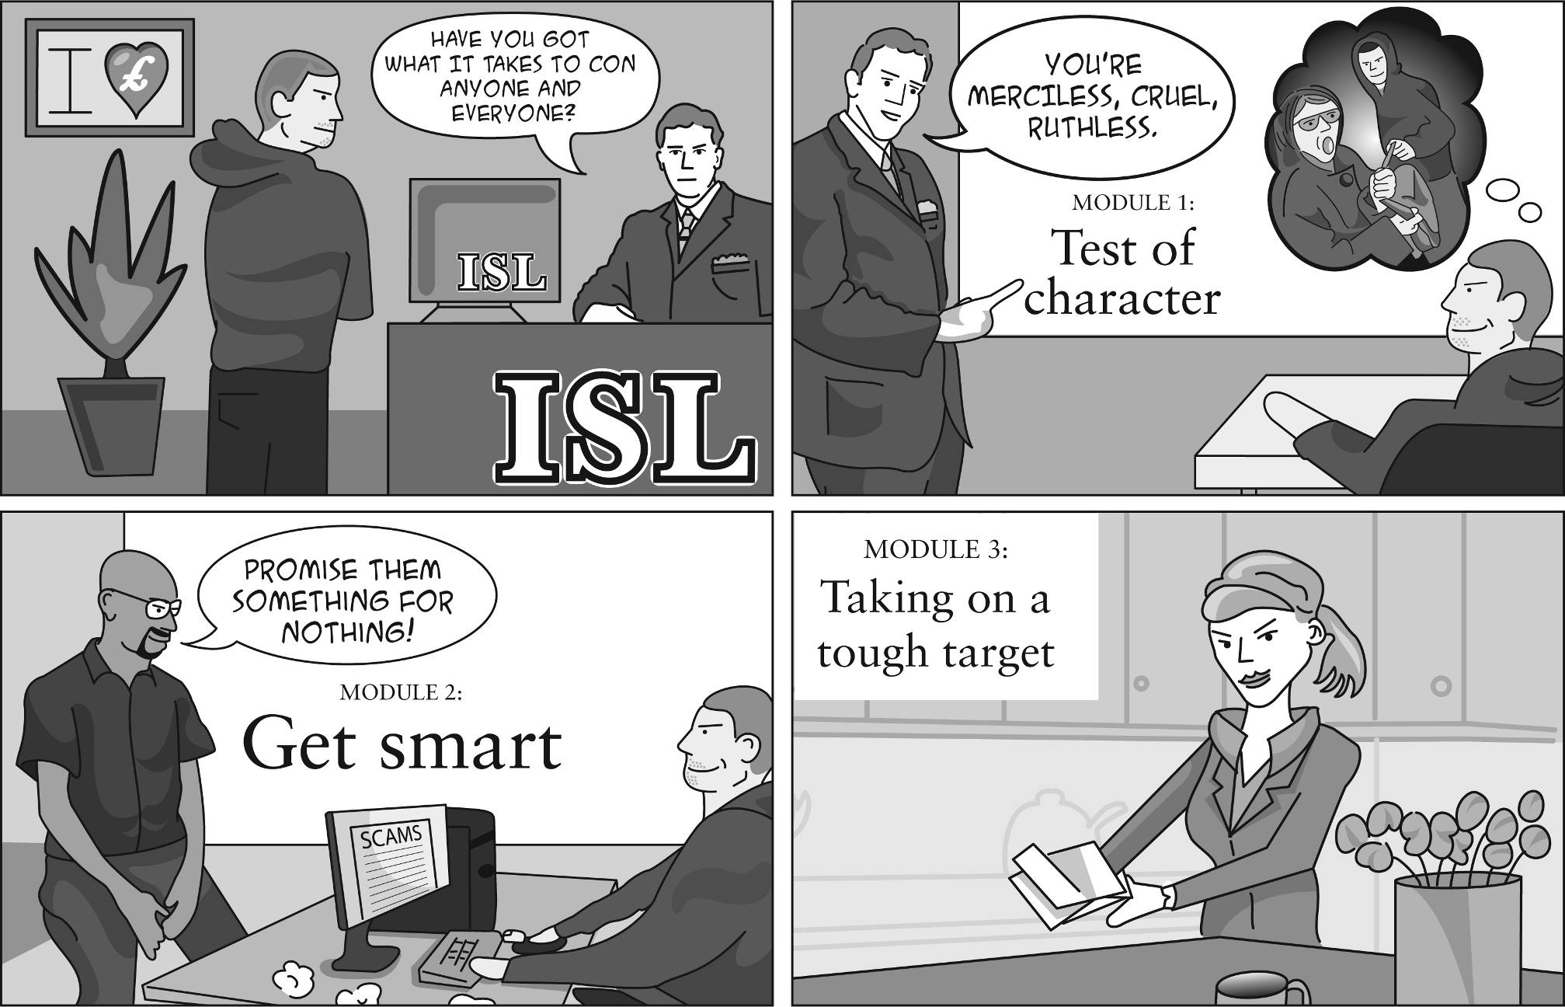
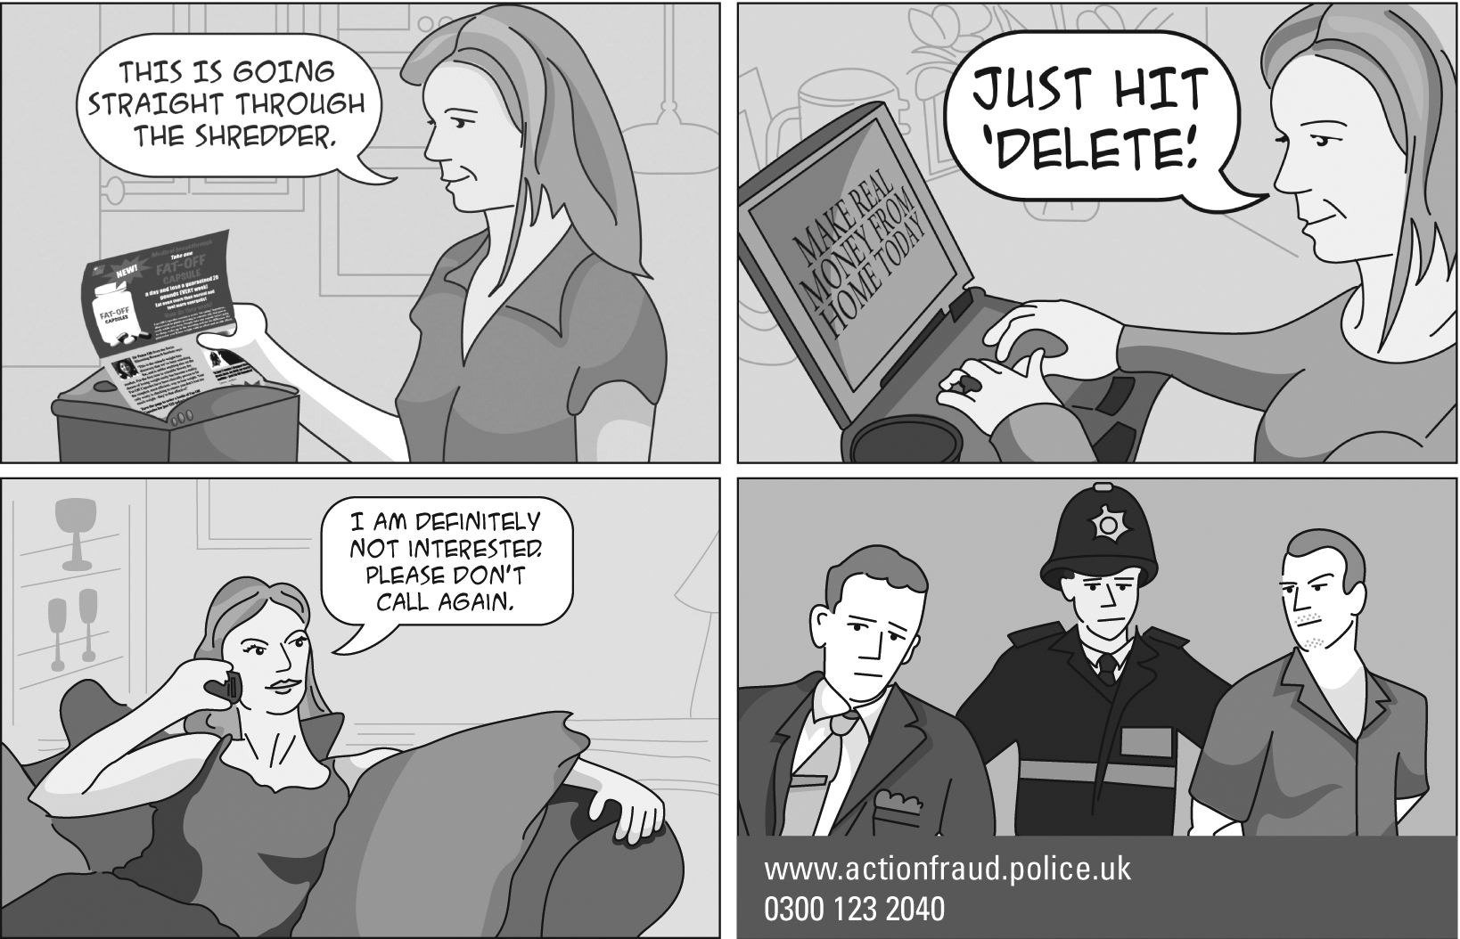

 | Scammer prompt card 1
Name | (Your name)
Position | Assistant vice president
Company name | The Euro International Lottery Board
Prize/offer | Congratulations! You have won one million euros on the Euro International Lottery.
Time pressure | There are only two weeks left for you to claim your prize, otherwise you lose it altogether.
Confidentiality | It’s important that you don’t mention this to anyone now. Wait and surprise your friends and family when you receive your cheque.
Action | Call your claims agent. His number is 078 123456. He’s waiting for your call right now.

 | Scammer prompt card 2
Name | (Your name)
Position | Stakeholder manager
Company name | The National Sweepstake Company
Prize/offer | Congratulations! I’m delighted to tell you that you’ve just won a very large cash prize.
Time pressure | There are only 10 days left for you to claim your prize.
Confidentiality | We need to ask you not to mention this to anyone yet. You can surprise your friends and family when we have finalised the paperwork.
Action | Call your claims agent. His number is 0940 372372. He’s expecting your call right now.

 | Scammer prompt card 3
Name | (Your name)
Position | Asset and prize manager
Company name | European Mediterranean Holdings
Prize/offer | You are the lucky winner of a fantastic free holiday in the Mediterranean for you and your family. All you need to do is attend a presentation.
Time pressure | There are only 7 days left for you to book your place at our prize winners’ presentation and collect your great prize.
Confidentiality | Please don’t mention this to anyone until after the presentation. You can surprise your family when you’ve chosen your Mediterranean destination.
Action | Book a place at the presentation now so you can collect your prize.

 | Scammer prompt card 4
Name | (Your name)
Position | Senior partner
Company name | Investment Group International
Prize/offer | You have been chosen for a one-off opportunity to join an exclusive investment scheme – giving you a guaranteed £200,000 tax free this financial year.
Time pressure | There are only a few places left.
Confidentiality | As this is an exclusive invitation, I’d strongly suggest that you don’t mention this to anyone.
Action | You can reserve your place at our exclusive members’ presentation with me now.

